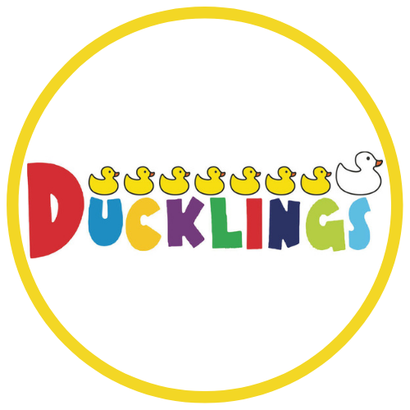

Term Dates
2021 - 2022

Term dates for Milton Keynes sites

Monday 6th September 2021 - school opens
Friday 22 October 2021 - school closes

^{Half term (25th-29th October)}
Monday 1st November 2021 - school opens
Friday 17th December 2021 - school closes

Christmas Holidays (20th - 31st December)
Tuesday 4th January 2022 - school opens
Friday 18th February 2022 - school closes

^{Half term (21st-25th February)}
Monday 28th February 2022 - school opens
Friday 8th April 2022 - school closes

Easter Holidays (11th - 22nd April)
Monday 25th April 2022 - School opens
*Bank Holiday: Monday 2nd May 2022*
Friday 27th May 2022 - school closes

Summer Half term (30th May - 3rd June)
Monday 6th June 2022 - school opens
Friday 15th July 2022 - school closes

Summer Holidays (18th July - )

Insert days will be confirmed due to Covid-19

Term Dates for Middleton Manchester

Monday 6th September 2021 - school opens
Friday 22 October 2021 - school closes (7 weeks)

Half term (25th - 29th October)
Monday 1st November 2021 - school opens (7 weeks)
Friday 17th December 2021 - school closes

End of term - Christmas Holidays (20th - 31st December)
Tuesday 4th January 2022 - school opens (6 weeks, 4 days)
Friday 18th February 2022 - school closes

Half term (21st - 25th February)
Monday 28th February 2022 - school opens (5 weeks)
Friday 1th April 2022 - school closes

End of term - Easter Holidays (11th - 22nd April)
Tuesday 19th April 2022 - school opens (5 weeks 3 days)
*Bank Holiday: Monday 2nd May 2022*
Friday 27th May 2022 - school closes

Summer Half term (30th May - 3rd June 2022)
Monday 6th June 2022 - school opens (7 weeks)
Wednesday 22nd July 2022 - school closes

Summer Holidays (25th July - 31st August 2022)

Insert days will be confirmed due to Covid-19

Term Dates for Didsbury Manchester

Tuesday 7th Sept 2021 - school opens
Thursday 21st Oct 2021 - school closes

HALF TERM (22nd - 29th October)

Monday 1st Nov 2021 - School opens
Friday 17th Dec 2021 - school closes

CHRISTMAS HOLIDAYS (20th - 31st December)

Tuesday 4th Jan 2022 - school opens
Friday 18th Feb 2022 - school closes

HALF TERM (21st-25th February)

Monday 28th Feb 2022 - school opens
Friday 1st April 2022 - school closes

EASTER HOLIDAYS (4th - 17th April)

Tuesday 19th April 2022 - school opens
*Bank Holiday: Monday 2nd May 2022*
Friday 27th May 2022 - school closes

SUMMER HALF TERM (30th May - 3rd June)

Monday 6th June 2022 - school opens
Friday 22nd July 2022 - school closes

SUMMER HOLIDAYS (25th July - )

Inset Days to be confirmed due to Covid-19.

Term Dates for Blackley Manchester

Monday 6th Sept 2021 - school opens
Thursday 21st Oct 2021 - school closes

HALF TERM (22nd - 29th October)

Monday 1st Nov 2021 - School opens
Friday 17th Dec 2021 - school closes

CHRISTMAS HOLIDAYS (20th - 31st December)

Tuesday 4th Jan 2022 - school opens
Friday 18th Feb 2022 - school closes

HALF TERM (21st-25th February)

Monday 28th Feb 2022 - school opens
Friday 1st April 2022 - school closes

EASTER HOLIDAYS (4th - 17th April)

Tuesday 19th April 2022 - school opens
*Bank Holiday: Monday 2nd May 2022*
Friday 27th May 2022 - school closes

SUMMER HALF TERM (30th May - 3rd June)

Monday 6th June 2022 - school opens
Friday 22nd July 2022 - school closes

SUMMER HOLIDAYS (25th July - )

Inset Days to be confirmed due to Covid-19.

