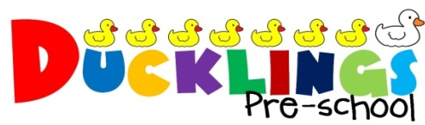

eyLog Registration and Consent
Child’s Name: ______________________ Date of Birth: ___________________
I have read the information about the eyLog system and understand that by signing this consent form I will receive an email message and will be able to log in and see observations of my child. These observations may include photographs, video clips or audio recordings.
I hereby give consent for my child to be photographed/videoed for record-keeping purposes and for the use of Early Years Professionals at Ducklings Preschool
I understand that there may be group photographs/videos that incorporate images of my child and other children and teachers. I agree that these photographs/videos may be used in other children’s learning journeys. To protect and respect privacy, I agree not to use/upload/share the photographs, videos and audio recordings involving other children on public web-sites such as social media websites and may not utilise information from my child’s learning journey for purposes other than understanding the development of my child.
Ducklings Preschool’s policy on photographs/videos covers this in more detail which I can access in the Policies Folder located on the parent table.
I agree that my child’s observations, learning journey, reports and other documents created through eyLog can be stored on eyLog’s systems. I agree to log in using only the personal log-in provided to me. The following email address(es) can be used to send me notifications through the eyLog system.
Your Name | Your e-mail ID | Relationship to the child | Your Signature

